# Creating Apps, Adding Entities and Pages

This case is the first in a series of introductory cases that explain the basics of Mendix. In this case you will learn to create apps and add pages to the project.

### Prerequisites

This case was prepared using version 7.21.0 of the desktop Mendix Modeler.

## Create the App

You can create an app using the desktop modeler or on the developer portal. If you create it on the developer portal, the version will be whichever the latest version of the Mendix Modeler is available. In either case, you can edit the app in the desktop modeler.

### Open the Desktop Modeler

Open the desktop modeler. The first screen you see is a list of the projects stored on your computer. There isn’t a way to organize this list so it’s a good idea to build the organization into the name of the app so you can use the search field to find groups of apps.

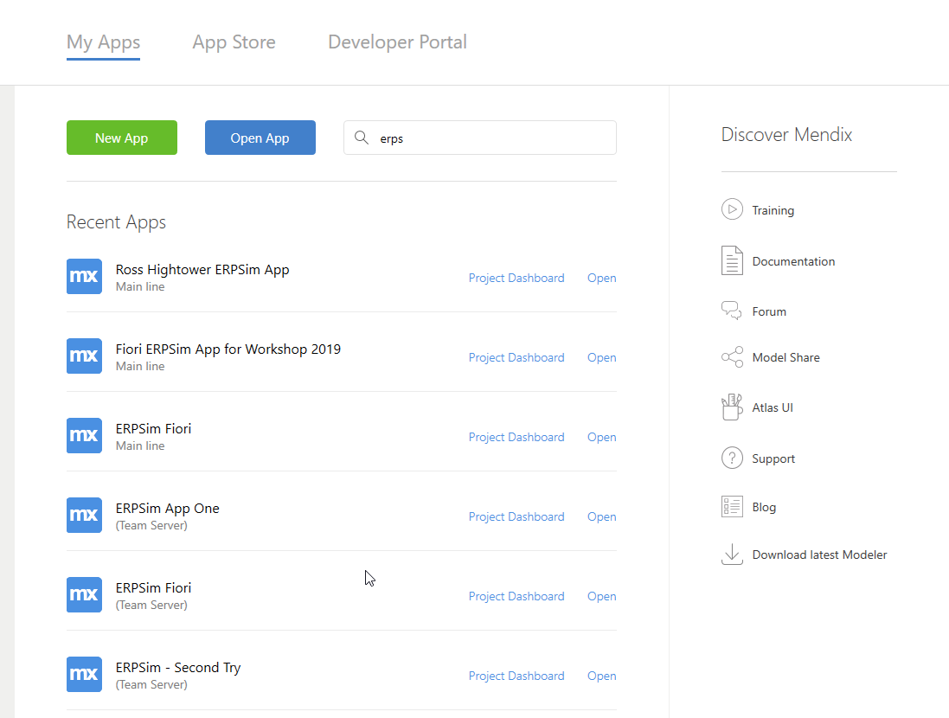

Notice that you can access the Mendix App Store and the Developer Portal using the buttons near the top of the screen.



You can also access a number of useful resources using the menu on the right.

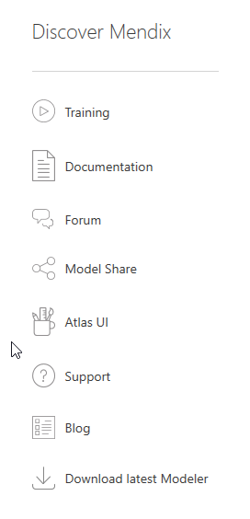

### Create the App

Click New App to create your app.



You can choose from a variety of templates to create the app.

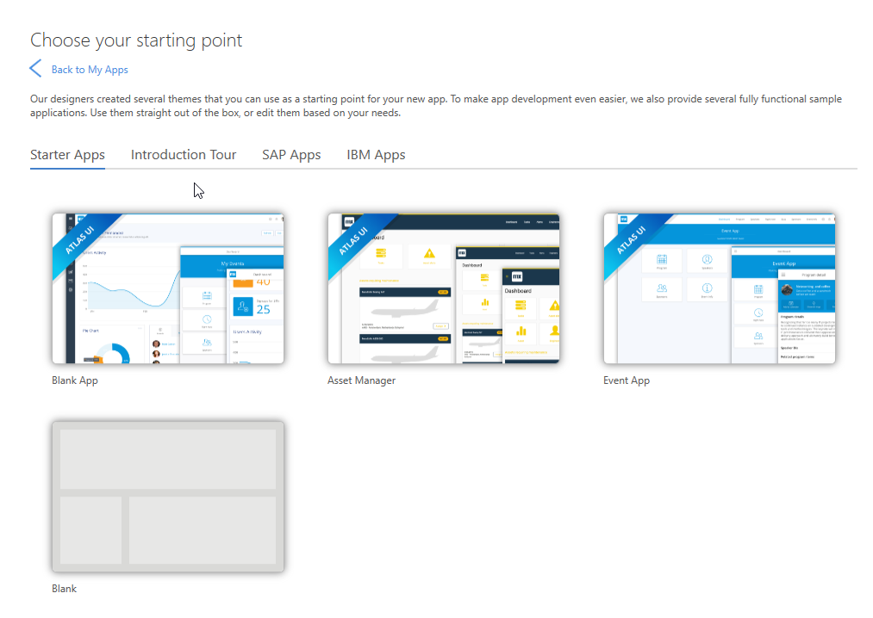

Click the Blank App.

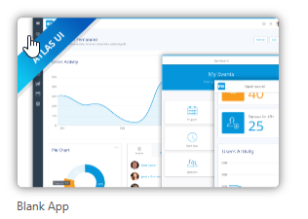

Click Use this starting point.

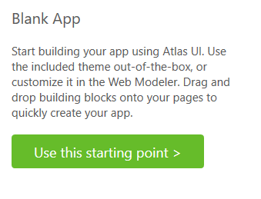

Enter a descriptive name for the app. You can also choose a folder for the project. Click Create app.

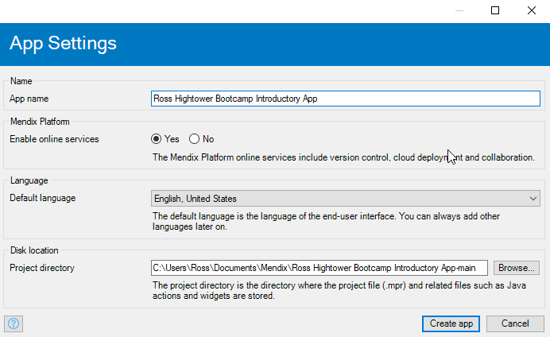

The app creation process takes some time. Once the app is created, it will be opened in the Mendix Modeler.

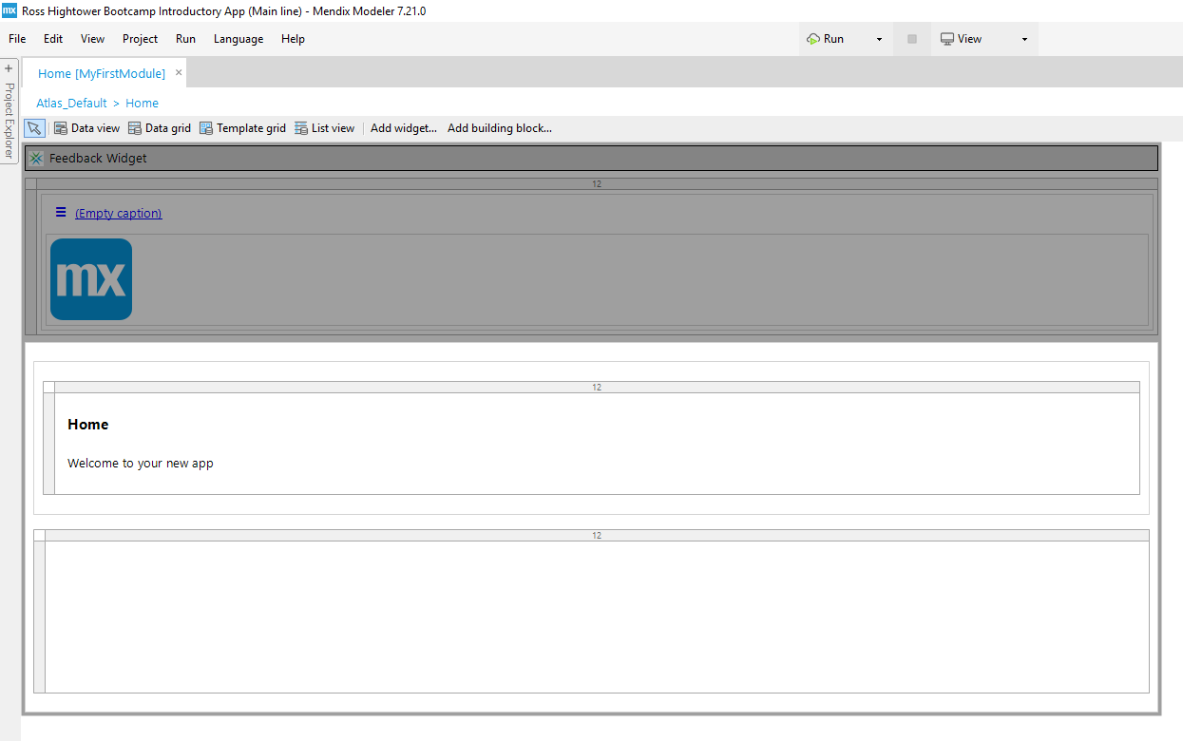

You will also find it on the Developer Portal which you can access at [home.mendix.com](http://home.mendix.com). Your apps are listed on the Apps page.

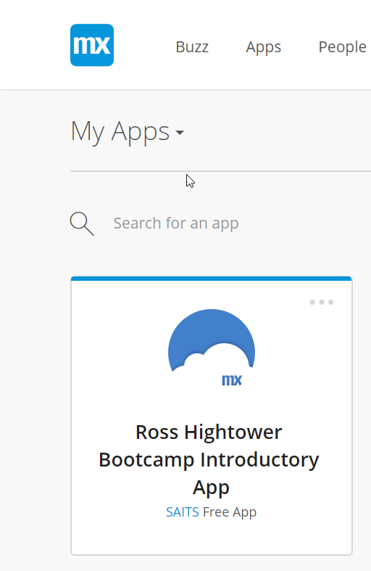

### Run the App

To run the app, you can use the dropdown button at the top-center of the modeler.

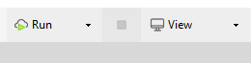

The run dropdown has two options: Run and Run Locally.

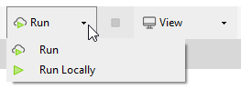

If you choose Run, the app will run in the Mendix cloud. If you choose Run Locally, the app will start a small application server on your computer and run the app locally. Most of the time you will want to run the app locally. You would choose to run in the Mendix cloud if you were trying to test cloud specific features or were deploying the app for production.

Select the Run Locally option and the project is *compiled.* When you see the following dialog, select Yes.

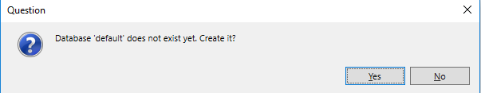

When the app is ready you will see a dialog like the one shown below, and the View dropdown will be enabled. Click View to run the app.

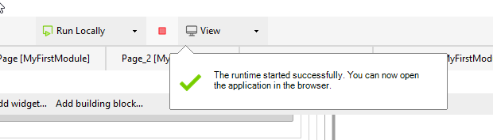

The app opens in a tab of your default browser. Note the hostname in the URL is localhost which refers to your computer.

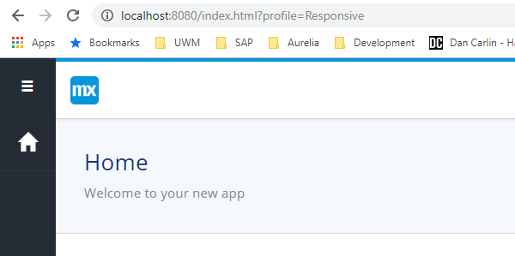

The View dropdown also has options that will allow you to see how the app performs on different screen sizes. The Blank app template only creates a navigation profile for the Responsive Browser and the Hybrd Phone App Online. Select the Hybrid Phone App Online.

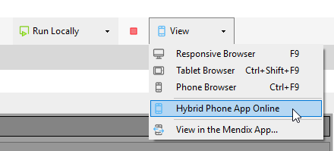

A new browser tab opens that looks like the image below. Note the interface adjusts to the smaller screen size automatically.

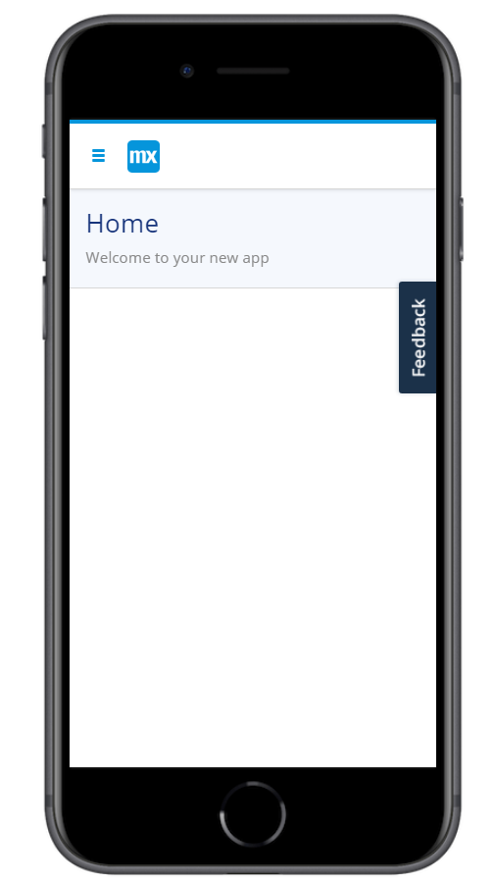

## Add a Product Page

The first thing we will add to the project is the functionality required to enter, edit and delete products. The steps are:

1. Creating the Product entity in the Domain Model
2. Adding a Products overview page
3. Adding a Products New/Edit page
4. Adding the Products overview page to the navigation model

### Add the Products Entity

The Project Explorer on the left side of the screen shows all the elements of the project.

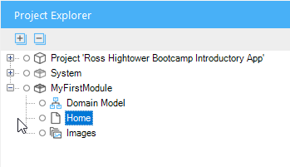

Mendix projects are organized into modules which can be exported and imported into projects as independent components. Initially, the Blank app template creates one module for your code called MyFirstModule. For now, we’ll leave the name unchanged, but it would be good practice to name the module something more meaningful.

Every module contains a Domain Model which is where we model the database elements of the project. The database in Mendix projects is a relational database.

Double-click the Domain Model to open it.

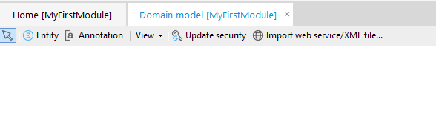

A toolbar above the editor includes the various options available for the Domain Model editor. You can add a database entity by clicking the Entity item on this toolbar then clicking in the editor canvas or by right-clicking the canvas and choosing Add entity.

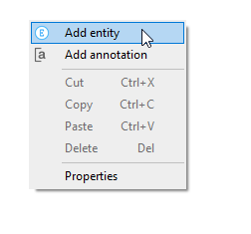

Add an entity.

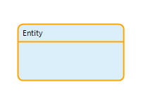

Double-click it to open its properties. Name the entity Product.

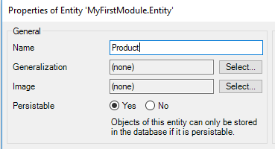

Add the following Attributes.

**Name Type**

ProductName String  
QuantityInStock Integer  
Price Decimal

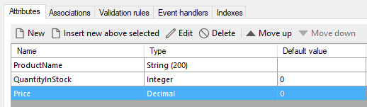

Click OK when you are done.

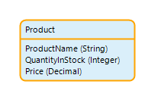

### Add a Product Overview Page

There are multiple ways to create the overview page. We’ll do it the manual way to make it clear what the steps are.

First, right-click the MyFirstModule module in the Project Explorer to create a new folder.

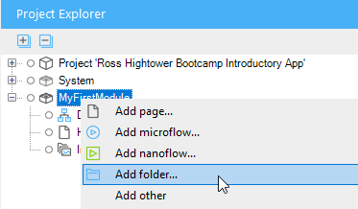

Name is Pages.

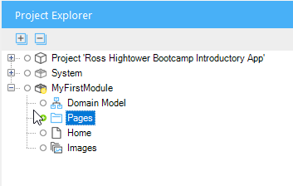

Right-click the Pages folder and select Add page… On the Create Page dialog, configure the page as shown below:

Page name ProductsOverview  
Navigation layout Atlas_Default  
Template category Grids  
Template Datagrid Default

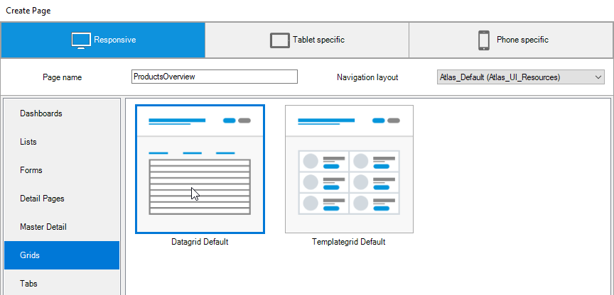

Click OK when you are done, and the page is created.

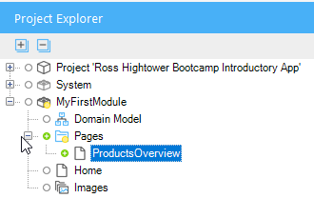

The page is also opened.

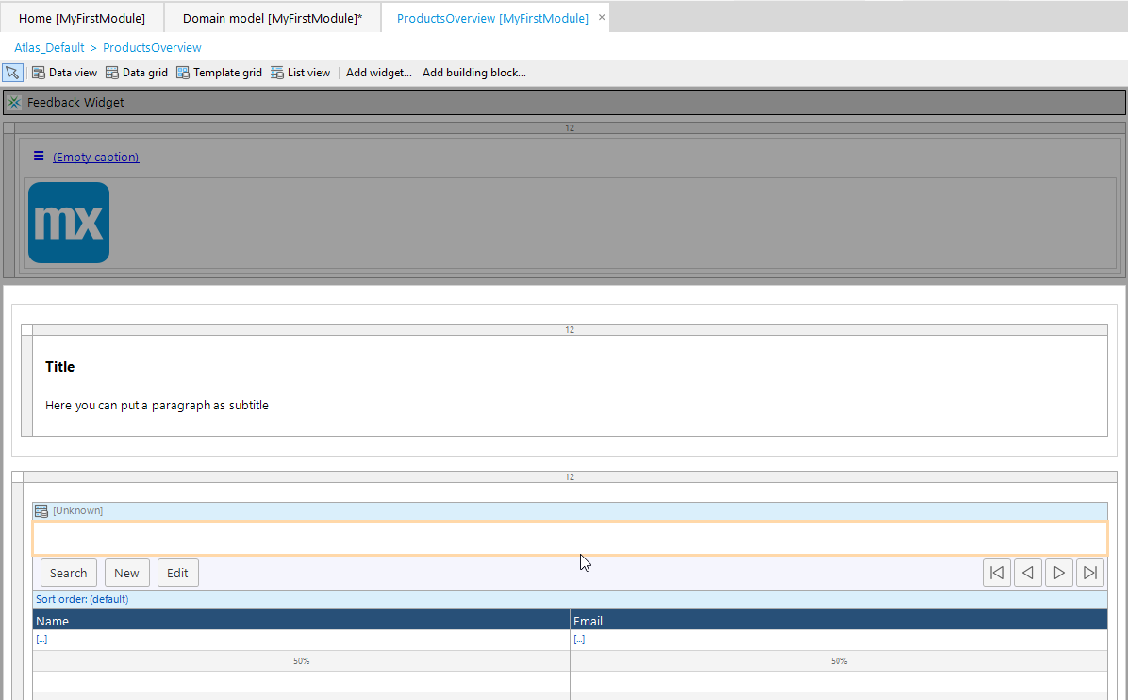

Double-click the Title Text widget and change the Caption to Products. Delete the subtitle Text widget by right-clicking it and selecting Delete.

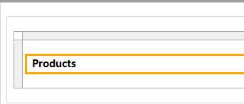

The page includes a Data grid widget which is a widget used to display a list of objects. Note the word Unknown in the header of the widget. This is because we haven’t configured the Data source for the widget.

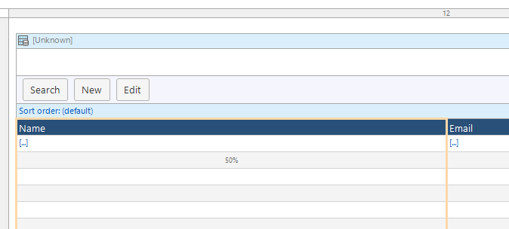

You’ll also see an error on the Error view which is complaining about the lack of data source for the Data grid.

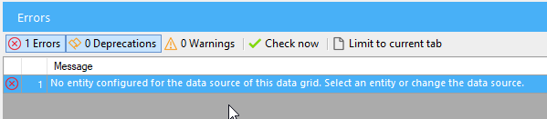

Double-click the header of the Data grid to open its properties. Click the Data source tab. Use the Select… button to select the Product entity as the data source.

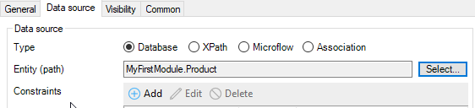

When you click OK, you will be prompted to fill the contents of the Data grid automatically. Choose Yes.

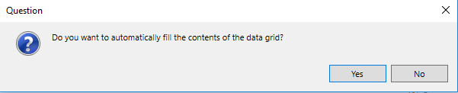

Three columns are created for the three attributes of the Product entity.

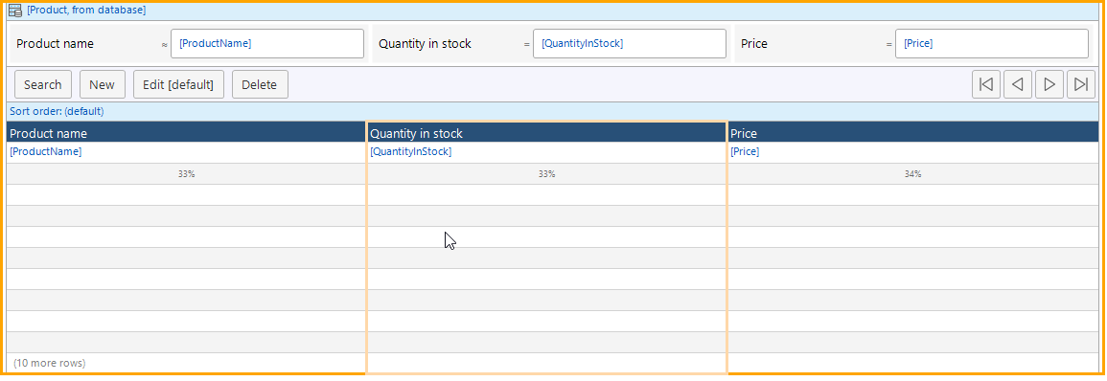

### Add a Product New/Edit Page

After configuring the data source for the Product Data grid, you will have two new errors.

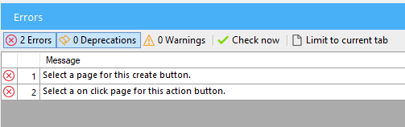

These errors refer to the fact that we have a New and Edit button on our Data grid but have not configured a page to perform these functions.

Right-click the New button and select Generate page…

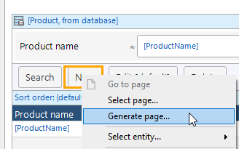

In the Create Page dialog that opens, leave the name, change the navigation layout to PopupLayout and select the Form Columns template.

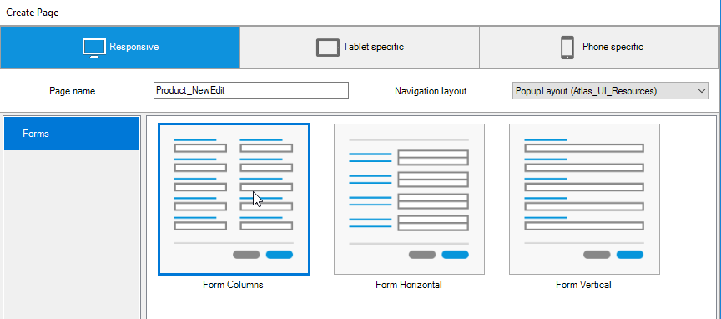

When you click OK, the page is created.

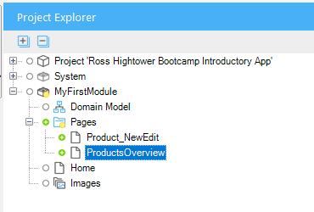

You can double-click the page in the Project Explorer to open it or you can right-click the New button on the Products Overview page and select Go to page. You will find a lot of handy shortcuts like this in context menus in the Mendix Modeler.

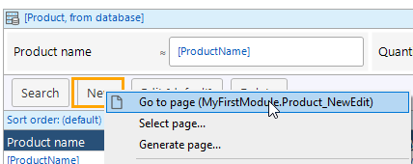

The Products_NewEdit page includes all three fields and the page creation wizard often chooses the correct widgets for the Attributes based on their data types.

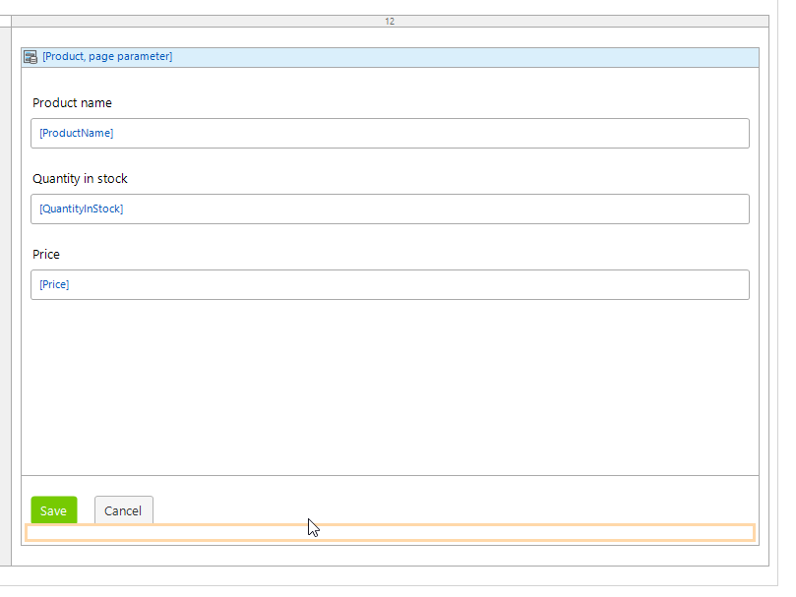

All the functionality required to enter, edit, delete and view products is complete. The only thing we need to do is to add the Products Overview page to the app’s navigation.

### Add the Products Overview Page the Navigation

Expand the Project node in the Product Explorer and open Navigation.

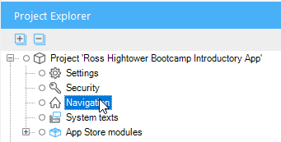

This screen is used to configure navigation in the app. You can add menu items to the app menu, configure different home pages for different types of users and create different navigation profiles for different types of devices. Note that there are two navigation profiles by default, the Responsive profile and the Hybrid phone app online profile. We viewed both of these earlier.

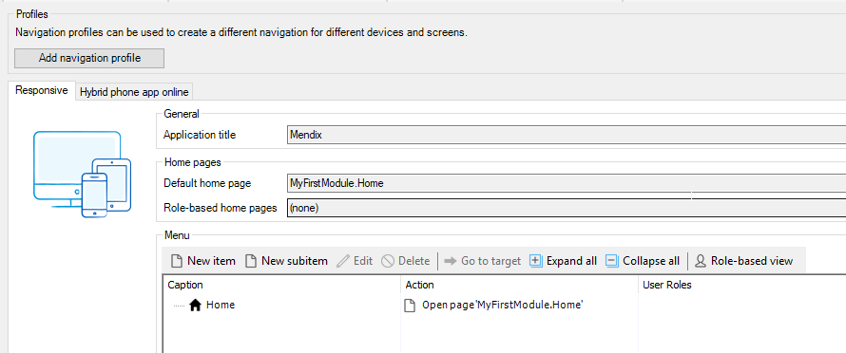

The Default home page field configures which page opens when the app is first opened. The items in the Menu editor at the bottom of the screen appear on the app’s menu. Currently there is only one item called Home. Click New item and configure it as shown below.

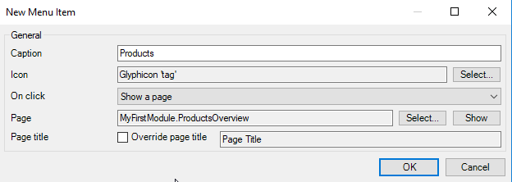

When you click OK, the item is added to the menu.

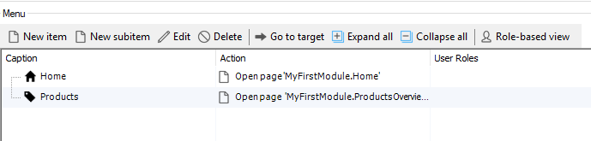

Click Run Locally to recompile the app. Whenever you change the Domain Model you will see a dialog like the one shown below when you run the app. Click Synchronize database.

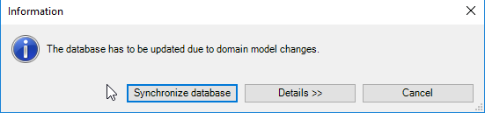

If the app is still open in a browser, the app will refresh automatically when it is ready (if it doesn’t, click refresh on the browser). If it is not already open, click View to open it once it’s ready. There is a new item on the menu. Click it to open the Products Overview page.

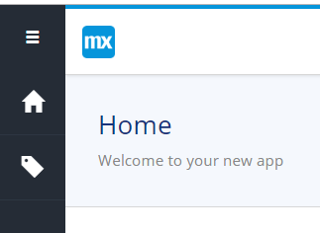

Click New to create a product.

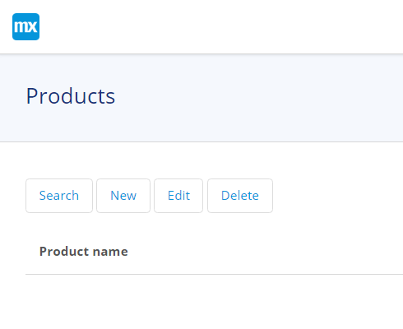

Create a product of your choice.

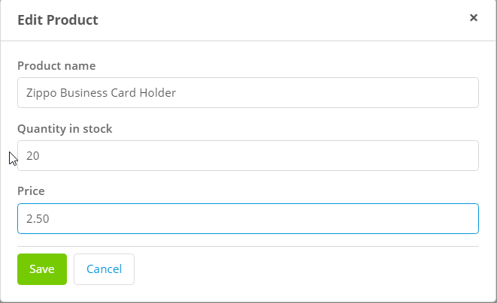

Create a few products.

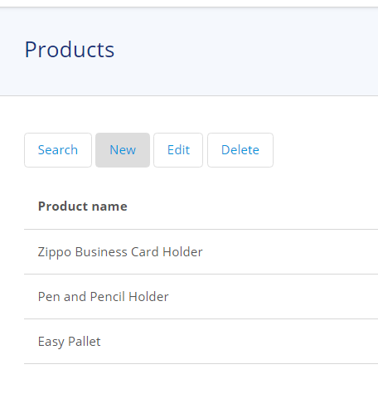

The Edit and Delete buttons work as well.

### View the Product Records

If you want to see the records in the database, you can open the database viewer using the Advanced dropdown menu on the Console view.

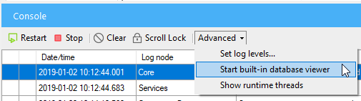

Locate the Product table and right-click it and choose SELECT….

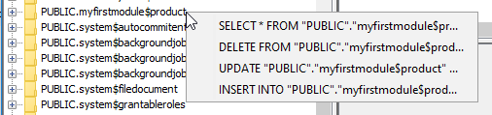

Click Execute SQL.



Note Mendix creates an attribute called id to be the primary key.

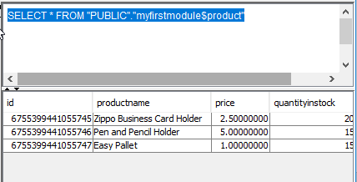

## Add a Customer Page

You can add the functionality to manage customers in the same way you did for products. This section will point out a few differences.

### Customer Entity

The Customer entity should look like this:

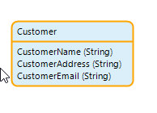

### Customer Overview Page

The customer overview page is like the Product overview page. Be careful when you create it because the PopupLayout navigation layout will likely still be selected.

### Customer New/Edit Page

One change to the Customer_NewEdit page is to change the widget used for the address. The default is the Text Box widget which only shows one line.

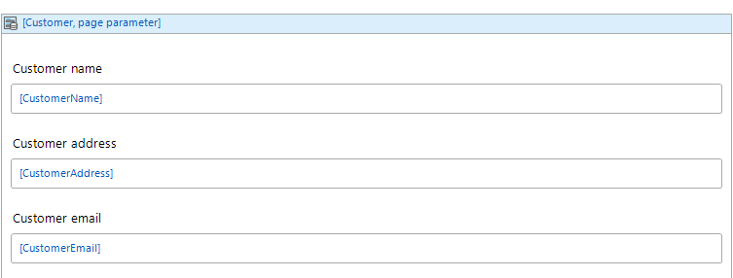

Right-click the Customer address widget and delete it. Open the Toolbox tab (usually on the right side of the Modeler) and drag a Text area onto the page where the address was previously.

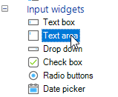

Double-click the Text area widget to configure its data source.

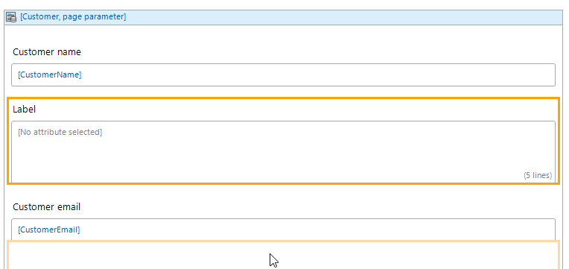

Use the Select… button to choose the CustomerAddress attribute.

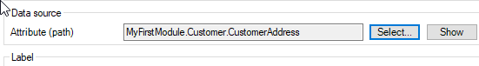

The result looks like this.

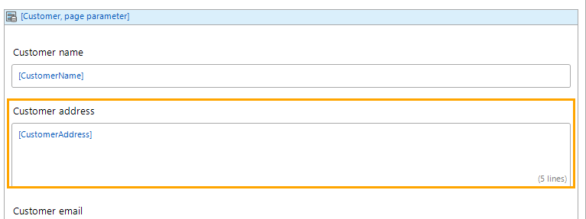

Remember to add the CustomerOverview page to the navigation then add a couple of customers.

